Vasko wants to play a board game with his friends. He chose “Colors”.
The game “Colors” consists of n points. There are also n-1 two-way connections, connecting two points and every point can be reached from every point “walking” on the connections. Each point also has a color c_{i}.
Vasko has already set the board and is now wondering whether he can win. To know that he needs the minimum and maximum distance between two points with the same color. The distance between two points is the amount of connections on the shortest path between them. You are a specialist of the game “Colors” so you need to help him.
Write a program which receives: n, the list of connections, and the colors c_{i} of every point and finds the minimum and maximum distances between two points with the same color.
Input
The first line of the file colors.in contains n – the amount of points.
The next n-1 lines contain two integers i j, meaning that there is a two-way connection between point i and point j.
The next line contains n numbers: c₁ c₂ c₃ ….. c_{n-1} c_{n} , denoting the colors of each point.
Output
On the only line of the file colors.out print 2 numbers – the minimum and the maximum distances between two points with the same color. If there are no such distances, print „-1 -1“.
Constraints
$$1≤n≤{10}^{5}$$
$$0 ≤c_{i}≤{10}^{18}$$
Time Limit: 1.5 sec.
Memory Limit: 256 MB.

Sample test
Input (colors.in) | Output (colors.out)
12  2 7  2 6  6 3  6 5  5 8  8 9  8 10  8 1  8 11  8 12  8 4  2 3 2 2 4 3 3 1 4 5 4 5 | 1 4

Sample Explanation
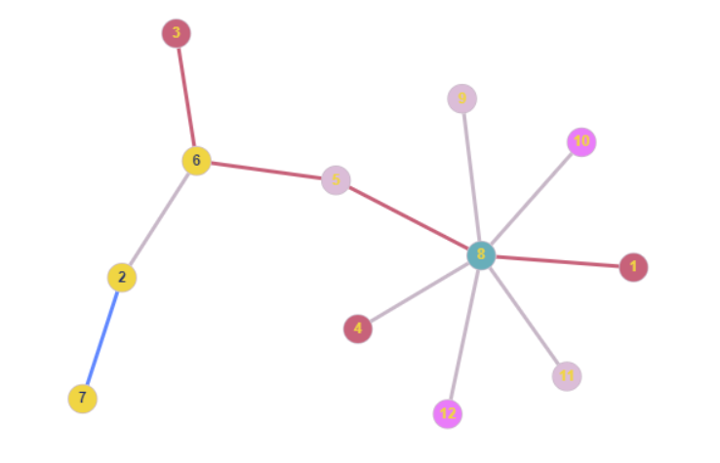
Points with the same color are colored the same. The minimum distance is in blue while the maximum is in red. It’s worth noting these aren’t the only minimum and maximum paths.

