Khan Kubrat had pondered, "Will my state too perish after my death?" He had summoned his five sons - Bayan, Kotrag, Asparuh, Kuber, and Alcek - and had said, "My sons, my earthly days are ending. Bayan, retrieve that bundle of sticks." Bayan had proceeded and had taken the bundle of sticks that had been lying by the fireplace, where the sacred eternal fire smoldered. "Now try to break them all at once." Kubrat had instructed him. Bayan had struck the bundle of sticks against his knee – they had not broken. He had struck a second time – still, they had not broken. On his third strike with all his might – the result had been the same. "Hand them to me now," Kubrat had requested. They had passed him the bundle, and he had started to extract the sticks individually, effortlessly snapping them – each one in succession. "If you separate after my death, you will each be broken individually. But together, like this bundle of sticks, no one will be able to conquer you," Kubrat had declared "Do you understand?". "We understand, unity is strength!" his sons had responded in unison.
After that Khan Kubrat had ordered his sons to put the sticks in the holes on the ground.
There had been n sticks and the stick with index i had a height $h_{i}$ . There had also been an infinite amount of holes, each of them with a depth of b. Every hole had been able to fit just one stick by width so the sticks in a hole had to be put on top of each other. Every hole had been able to fit a set of indices M of the sticks given that $\sum_{i∈M}{h_{i} ≤b}$ .
The task of the sons had been to put the sticks in the least amount of holes possible.
Khan Kubrat had decided that this task would be too easy so he had also told them that every stick had a penalty p_{i} . He had told them that for every hole it was allowed for one stick to be sticking out of it (given that at least part of the stick is underground), but in that case the penalty of the stick p_{i} would have been taken into account.
The legend doesn’t say how Khan Kubrat’s sons put the sticks, so it is your task to find a possible solution of his problem.
You are given n, b, the heights and penalties of each stick and your task is to put every stick in a hole, so that an optimal solution is found (see the Grading section).
Input
The first line of the file sticks.in contains n and b – the amount of sticks and the depth of the holes. The next line contains n numbers - $h_{1}, h_{2}, … , h_{n}$, the heights of the sticks. The last line contains n numbers - $p_{1}, p_{2}, … , p_{n}$ , the penalties of the sticks.
Output
On the first line of the file sticks.out print 1 number k – the amount of holes in which you have put the sticks.
On the next k lines describe the sticks in the corresponding hole – first print $d_{i}$ - the number of sticks in the hole, and after that the indices of the sticks $stick_{1}, stick_{2}, … , stick_{d_{i}}$. The sticks need to be in the order in which they are put: stick₁ is at the bottom, while $stick_{d_{i}}$ is at the top and is the stick that could possibly be sticking out.
Grading
If 1) there is a stick not in a hole, 2) there is a stick in more than 1 hole, 3) there is a stick completely above ground, 4) the amount of holes k is more than n, or 5) the amount of sticks d_{i} in a hole is more than n, you will receive the message “Error” and 0 points for the tests. Otherwise:
Let $S$ be the set of indices of the sticks, sticking out from the ground.
$$spenalty=\sum_{i∈S}{p_{i} }$$
$$yourScore= k^{3}+spenalty$$

For every test let minScore be the smallest score among the scores of all participants and yourScore is your score. You will receive
$1-\sqrt{1-\frac{minScore+1}{yourScore+1}}$ multiplied by the amount of points for the test.

Constraints
$$2≤n≤{10}^{6}$$
$$1≤h_{i}≤{10}^{7}$$
$$1≤b≤{10}^{10}$$
$$1≤p_{i}≤{10}^{12}$$

Time Limit: 5 sec.
Memory Limit: 256 MB.

The tests are spread like this:
Percent of tests | n
10% | $$2≤n≤10$$
10% | $$10≤n≤100$$
20% | $$100≤n≤1000$$
20% | $$1000≤n≤10000$$
20% | $$10000≤n≤100000$$
20% | $$100000≤n≤1000000$$

Sample test
Input (sticks.in) | Output (sticks.out)
7 9  3 4 1 8 4 7 3  3 2 6 10 5 3 3 | 3  2 4 3  3 1 7 2  2 5 6

Sample Explanation

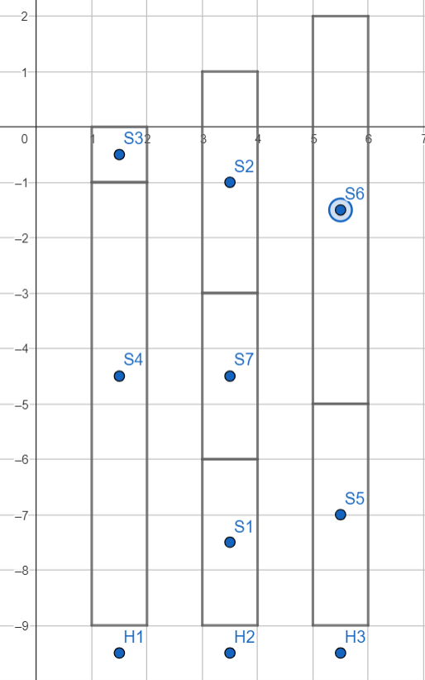
The sticks are labeled with S1, S2, …, S6 and the holes with H1, H2, H3. Every hole starts at -9, while the ground’s surface is at 0. We can see that the only sticks sticking out are 2 and 6, so spenalty = p₂ + p₆ = 2 + 3 = 5. Therefore the score of this solution is 3*3*3 + 5 = 32.

