QUEENS
Ivancho began playing a variation of a popular game in which the player has to place 8 queens on a chessboard so that no two queens attack each other.
The game Ivancho plays is different from the classic one because there are a few additional conditions in it:
- Instead of on a chessboard, the game is played on a square board with size N*N, divided into small squares(cells) with size 1*1
- Instead of being black and white, the fields of the board are filled with integers
- An attack range of the queens is given. Each one of them doesn’t necessarily attack the cells up to the edges of the board, but only the ones at a distance of at most R cells away from the one the queen is in.
- It is allowed to have K pairs of queens that can attack each other. In case queen 1 attacks queen 2 and queen 2 attacks queen 1. We assume that we have one pair of attacking queens.
- Every queen attacks all others in its range. I.e. two queens attack each other even if there are one or more between them.
- In one cell we can place one queen at most.
- Every queen on the board gives points equal to the sum of the numbers in the cells attacked by it with the cell in which the queen is placed being counted 4 times. This sum is multiplied by the number of encounters of the most frequently encountered number. The number in the cell the queen is placed in is counted 4 times when finding the most frequently encountered number, too!

After 3 weeks, Ivancho will be on a date with a beautiful girl, who is a big fan of this game. In that period of time, you must help him impress her - write a program called queens, which, with given N, R, K and a table with dimensions N*N representing the numbers in each cell of the board, places queens in the table in a valid way such that the sum of the score received by them is as large as possible.

The following images show the main rules.
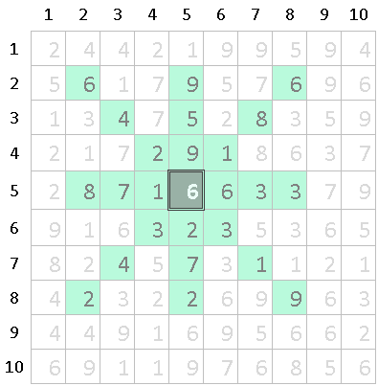 | N=10, R=3  A queen is placed in the dark cell. Its range is 3 and the green cells are the ones attacked by it.  The numbers in these cells are:  S = { 6, 9, 6, 4, 5, 8, 2, 9, 1, 8, 7, 1, 6, 6, 6, 6, 6, 3, 3, 3, 2, 3, 4, 7, 1, 2, 2, 9 }  Sorted, S is: S = { 1, 1, 1, 2, 2, 2, 2, 3, 3, 3, 3, 4, 4, 5, 6, 6, 6, 6, 6, 6, 6, 7, 7, 8, 8, 9, 9, 9 }  Obviously, the most frequently encountered number is 6 (7 times). The sum of all numbers in S is 135. Therefore, the queen placed in that cell will give the player 7*135=945 points.
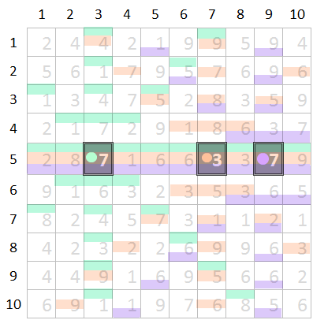 | N=10; R=8  We place 3 queens on the cells marked with gray colour. Each one of them attacks the cells with their respective colours.  There are 3 pairs of queens attacking each other (every queen attacks all others):  - (5,3) - (5,7)  - (5,3) - (5,9)  - (5,7) - (5,9)

Input
At the first line of the input file queens.in there are three integers N, R and K. N is the size of the game board, K is the maximum number of pairs of queens that can attack each other and R is their attack range. Each of the next N lines contains N integers separated with a space - respectively the values of the numbers in the game board.
Output
On each row of the output file queens.out you must print pair of integers separated with interval. These numbers represent the coordinates of each of these queens. First you must print the row in which the queen has been placed and after it - the column.
Note: The indices of the rows and columns start from 1, not from 0!
Evaluation
You will get 0 points if your output is invalid. Invalid is every output to which one of the following conditions applies:
  - The position of any queen is invalid - it has been placed outside of the game board or two queens are in the same cell
  - The number of the integers in the output file is odd or equal to 0
  - You print something other than an integer (for example, a string) even if it’s after the description of the queens
  - The pairs of attacking queens are more than K.
If your output is valid you will receive 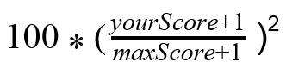 percent of the points for that test. yourScore is defined as the points Ivancho has received when running your program. MaxScore is defined as the points Ivancho has received when running the best program for that test.

Constraints:
1 ≤ N ≤ 200
1 ≤ R < N
0 ≤ K ≤ 1000
1 ≤ value of each cell in the table ≤ 50

% of all tests | 10% | 10% | 10% | 20% | 50%
max N | 10 | 25 | 50 | 100 | 200

Time limit: 5s  Memory limit: 256 MB | Preliminary tests: 15  Final tests: 100

Example test
queens.in | queens.out
6 3 6  2 4 7 5 2 5  7 7 3 1 2 2  2 4 2 4 4 7  4 5 8 5 7 2  5 7 6 5 7 8  8 7 4 3 6 1 | 1 3  1 5  3 2  3 4  3 6  4 4  5 1  5 5  6 3
Points: 4888

Example explanation
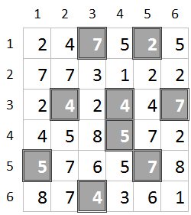 | N=6; R=3; K=6  In gray we mark the positions of queens that we must place on the example board so that we will achieve maximal score for that test.  Pairs of queens that attack each other:  - (1,3) – (1,5)  - (1,3) – (4,3)  - (3,2) – (3,4)  - (3-4) – (3,6)  - (3-4) – (4,4)  - (4,4) – (5,5)

