This time Ivancho is in trouble. Up against him is his worst enemy – Sashka’s father.
Some time ago Ivancho constructed a robot which goes through a room in a straight line without colliding with “unstable” fields. But in order to sabotage him, Sashka’s father is planning to create new “unstable” fields so that Ivancho’s robot would not be able to pass through them. What is more, the villain wants to create them in such a way that a robot with arbitrary width would not be able to pass even if it moves freely, i.e. not only in a straight line.
In order to prevent this disaster Ivancho need to know the minimal total length of “unstable” fields which Sashka’s father would need to create.

More formally, the room represents a square given by the coordinates of its bottom left corner (0, 0) and the coordinates of its top right corner (1000, 1000). There are N “unstable” fields in the room – these are segments (x1, y1, x2, y2) with x1, y1, x2, y2 being between 0 and 1000. You must find the minimal total length of segments which need to be added so that you cannot go from the left wall to the right wall. In other words, every curve with ends lying on the segments (0, 0, 0, 1000) and (1000, 0, 1000, 1000) respectively which does not leave the room must intersect with at least on segment.

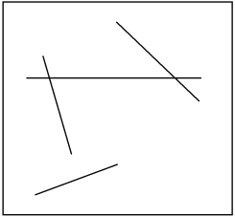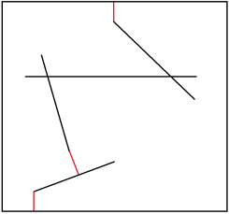
New unstable fields are shown in red.

Input
The first line of the input file block.in contains the integer N. Each of the next N lines contains four integers x1, y1, x2, y2 representing the coordinates of the first point and the second point respectively.

Output
In the output fie block.out write a single real number – the minimal total length of the new “unstable” fields. This number must be formatted with two numbers after the decimal point.

Constraints
0 ≤ N ≤ 2.10³

Time limit: 1 sec
Memory limit: 256 MB

Example
Imput (block.in) | Output (block.out)
3  100 100 200 400  800 699 800 1000  300 200 700 200 | 699.00
8  900 100 700 300  700 350 900 500  900 550 700 700  650 700 500 500  450 500 300 700  100 750 500 760  100 800 100 950  500 800 500 960 | 434.98

Explanation
- 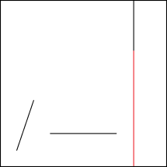

- 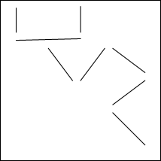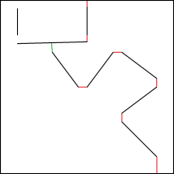
Pay attention that the fraction in the answer is resulted by the fact that the green “unstable” field is not horizontal.

Notice – when outputting double numbers in C/C++ with printf use %f and for long double use %Lf.

