Lora recently got tired of interacting with humans and decided to start a new life with her dogs far away from society. She now wants to surround her newly-built house with a fence, to be sure that no intruders will bother her.
We can represent Lora’s house as a single point with coordinates (0, 0). Near Lora’s house are several poles, which we can also represent by integer coordinates. Lora can connect two poles with a fence along a straight line. She now wants to connect some pairs of poles in such a way that the poles and their connections form a convex polygon with minimal area, such that Lora’s house is strictly inside it.
Your task is to write a program, that computes the minimal possible area of such convex polygon. To make things easier, you should print an integer – the area of the polygon multiplied by 2 (it is guaranteed that the area multiplied by 2 will be an integer).

Note: The connection of two poles cannot go straight through Lora’s house!

Input
The first line of the file fence.in contains a single integer N – the amount of poles near Lora’s house. The following N lines describe the poles. The i-th of those lines contains a pair of space-separated integers X_{i} and Y_{i} – the coordinates of the i-th pole.

Output
In the output file fence.out print a single integer – the minimum area of such convex polygon, multiplied by 2.

Constraints
3 ≤ N ≤ 400
-10⁶ ≤ X_{i},Y_{i} ≤ 10⁶

Time limit: 1.0 sec
Memory limit: 256 MB

Example test
Input (fence.in) | Output (fence.out)
4  -1 2  -1 -1  1 -1  0 -3 | 6
4  -1 2  1 2  0 1  0 -1 | 6
5  -1 2  1 2  -1 -2  1 -2  4 0 | 16

Clarifications
The solutions of the sample tests are as follows (the poles are marked with red dots and Lora’s house with a blue square):
Sample case 1 (area=3):
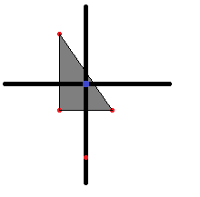
Sample case 2 (area=3):
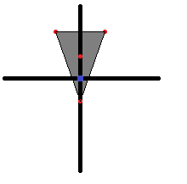

Sample case 3 (area=8):
