For Christmas Lora received many gifts. Even though the collection of exotic teas and the Harry Potter slippers were great, the best gift was undoubtedly a pinball machine. We can describe the game on the machine as follows:
The inside of the machine is a matrix with N rows and M columns, each cell in it being either empty (denoted by the '.' symbol) or containing one of two types of objects (indicated by '\' and '/'). The rows are numbered with the integers from 1 to N and the columns are numbered with the integers from 1 to M. Initially, a player rolls a ball into the machine by choosing one of the rows of the matrix and releasing the ball into the first cell of it with a direction of movement to the right, after which the movement of the ball is set by the following rules:
- If the ball is in an empty cell, it moves one cell in the direction of movement.
- If the ball is in a cell containing an object, it crashes into the object and changes its direction of movement by 90 degrees, depending on the object, respecting the rules of reflection. For example, if a ball pointing rightwards bumps into the object '\', the ball will continue downwards, and if a ball pointing upwards bumps into the object '/', the ball will continue to the right. After the collision the object breaks and the cell is considered empty until the end of the game.
- If the ball leaves the matrix, the game ends.
Each cell gives a certain number of points to the player when the ball passes through it. If, during the game, the ball goes through a cell more than once, the player receives the points from the cell each time the ball passes through it.
To make the player more involved, the machine allows changes to the matrix with the cost of penalty points that are subtracted from the final result after the game ends. The changes are done before the game starts. The allowed changes to the matrix are:
- Place an object in an empty cell. This change adds A penalty points for each added object.
- Change the type of an object ('\' to '/' and vice versa). This change adds C penalty points for each modified object.
The final score is equal to the points earned from the ball movement minus the penalty points. If the final result becomes negative, it is considered 0. Help Lora win as many points as possible in one game.
Note: The complete removal of an existing object is not allowed.

Input
The first row of the file pinball.in consists of two integers – N and M – respectively the number of rows and columns in the matrix of the machine. The second row consists of two more integers – A and C – respectively the penalty points for adding an object and changing an object. Then N rows follow, each of them containing, without separators, M symbols - the matrix describing the machine. Then N more rows follow – each of them contains M integers, separated by intervals - the points that are earned for each visit of the respective cell.

Output
On the first line of the output file pinball.out print one number – the row from which the ball starts. On the next N rows, print the final matrix in the machine, after all the changes, in the same format as in the input.

Constraints
- 1 ≤ N, M ≤ 400
- 0 ≤ A,C ≤ 20 000
- 0 ≤ points earned for passing through a cell ≤ 1000
- Time limit – 5 seconds
- Memory limit – 256MB

Subtasks
Amount of tests | Additional constraints
10% | 1 ≤ N, M ≤ 10
other 15% | There are only empty cells in the matrix
other 15% | All cells give the same amount of points
other 10% | A=C=0
other 50% | There are no additional constraints

Scoring
You will receive 0 points if your output is invalid. An invalid output is any output that is either incorrectly formatted or attempts to completely remove an existing object.
If your output is valid you will receive $100×{\left(\frac{yourScore+1}{maxScore+1}\right)}^{2}$ percent of the points for the test. We define yourScore as the result of your program and maxScore as the largest result of any of the programs of all competitors.

Sample test

Input (pinball.in) | Output (pinball.out)
4 4  5 3  /...  ....  ....  ..\.  2 5 5 3  7 4 6 1  4 4 4 4  7 2 1 5 | 4  /.\.  ....  ....  ../.

Test explanation
The given solution is one of many possible ones and is not necessarily optimal. There are two changes in the matrix – one addition and one modification of an object. The penalty points are hence 5+3=8. The ball starts in the first cell of row 4 with movement direction to the right. We can track its route:
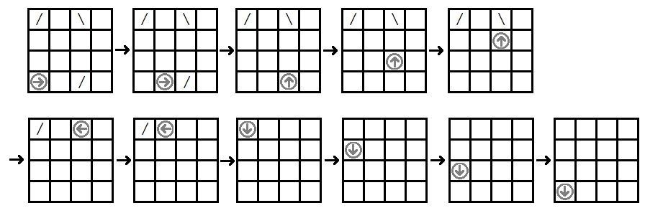
The cells the ball passes through give 7+2+1+4+6+5+5+2+7+4+7=50 points. Subtracting the 8 penalty points we get the final result for this solution – 42 points.

