As you already know, Lora spends all of her time playing online games and puzzles. In today’s game Lora has a table of N rows and M columns. The rows are numbered from 1 to N from top to bottom and the columns from 1 to M from left to right. Each cell in the table is either free (denoted by the ‘.’ symbol) or blocked (denoted by the ‘# symbol’). A level in the game consists of K robots, waiting to be given a motion command. At each step, Lora can give a command to all robots at once. The commands are:
‘N’ – move one cell up
‘E’ – move one cell right
‘S’ – move one cell down
‘W’ – move one cell left
When given a command all robots try to execute it, but only those who can actually do it. A robot can execute a command if the cell in which it will end up after the execution is not out of the table and is not blocked. Note that the robots do not interfere with each other and at any moment (even at the beginning) there may be any number of robots in a given cell. Lora’s goal is to move all robots in the same cell with a minimum number of commands. If this is too hard, then Lora aims to move the robots as close to each other as possible (look at the “Scoring” section for more details on how the result of a game is calculated). It is guaranteed that there is a path from adjacent free cells between every two robots in one level.
There are T levels in the game, but the end of the working day is near and Lora has time to play just one of them. In order to leave in good mood, she wants to achieve the best possible result. Help her by making a program that chooses the most appropriate level and commands to give in it. Your solution should use at least one and not more than 100 000 commands.

Note: The levels consist only of differences between the starting positions of the robots. After selecting a level, the remaining levels are not considered when executing the commands.

Scoring
The distance between a robot on row x₁ and column y₁ and a robot on row x₂ and column y₂ is defined as |x₁-x₂|+|y₁-y₂| (Manhattan distance). Note that this distance estimate ignores blocked / free cells.
Let your solution use C commands. We define D as the biggest (Manhattan) distance between two robots after all commands have been executed. Then your result is C+D*(N+M).
If your output is invalid, you will get 0 points for that test.
If your output is valid you will get $100×\frac{minScore+1}{yourScore+1}$ percent of the points for this test, where minScore is the smallest result achieved by a participant and yourScore is your result on this test.

Input
The first line of the input file robots.in consists of two integers N and M – respectively the rows and columns of the table.
Then N lines follow that consist of strings of M symbols (without separators), describing the table. Each of the symbols is either ‘.’ or ‘#’.
The next line consists of two integers T and K – respectively the number of different levels and the number of robots in each level.
Then T groups of K lines follow, each line containing two integers – the starting row and column of a robot in the respective level.

Output
On the first line of the output file robots.out print one integer from 1 to T – the level you will be playing. On the next line print, without separators, a string of characters ‘N’, ‘E’, ‘S’, ‘W’, indicating the commands that all robots will execute in the order in which they should be executed. Your solution should use at least one and not more than 100 000 commands.

Constraints
5 ≤ T ≤ 10

Number of tests | N, M | K
20% | 10 ≤ N, M ≤ 50 | 4 ≤ K ≤ 20
20% | 50 ≤ N, M ≤ 100 | 4 ≤ K ≤ 20
20% | 100 ≤ N, M ≤ 150 | K = 2
40% | 100 ≤ N, M ≤ 150 | 4 ≤ K ≤ 20

Test generation
A test generator with the same structure as the one used to generate all tests, as well as a file with a detailed description of the generation approach are provided.

Time limit: 5 seconds
Memory limit: 256 MB

Sample test
Input (robots.in) | Output (robots.out)
4 5  .#..#  ....#  #.#..  ...#.  2 2  1 1  4 5  4 1  4 5 | 2  ENWNEE

Test explanation
We choose the second level with robots on positions (4, 1) and (4, 5). The game goes the following way:
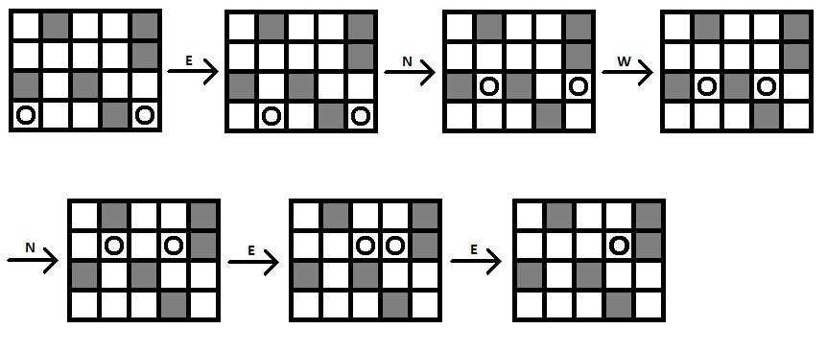
Since all robots are collected in one cell, the result for this output is 6 – the number of commands.
Alternatively, if we had missed the last command and the output was only “ENWNE”, the result would have been 5 + 1 * (4 + 5) = 14, since the biggest distance between two robots would have been 1.

