Problem 4. Fence(fence)

The farmer Pesho finished fencing his infinite field and all he has left is painting the fencing.
The fencing consists of metal sticks, connected with straight wooden fences. It is known that between every two sticks there is no more than one fence, that every fence connects exactly two different sticks and that no two fences cross. The fencing splits the field into K areas(К is equal to the size of the largest set of points on the field, such that no two points from the set can be connect with a curve, without crossing a fence).
Pesho wants to know how many segments of fence should be painted in each area.
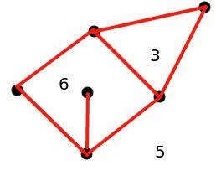
In the picture above there are three areas - an outer area, a square and a triangle. In the outer area five walls should be painted, in the triangle - three, in the square six (the fence going inside the square is counted twice - because its two sides should be painted).
Write the program fence, which takes as an input the fencing and prints the number of areas and the numbers of segments of fence to be painted in each area.

Input
On the first line of the input file fence.in there are two numbers N and М - the number of metal sticks and the number of wooden fences.
On N lines consist of 2 numbers each - the coordinates Xi, Yi of the i-th stick.
Next there are M lines, with two numbers on each: Pi and Qi - the numbers of the sticks, connected by the i-th fence.

Output
On the first line of the output file fence.out is the number K - number of areas.
On the next line K numbers follow, separated with one space - the number of fences to be painted in every given area, printed in non-decreasing order.
Constraints:
3 N 100,000
-100,000 Xi,Yi 100,000
All numbers in the input are integers.
All metal sticks belong to the same component.

Time Limit: 3s

Example:
fence.in | fence.out
6 7  2 1  1 2  2 2  3 2  2 3  3 3  1 2  1 3  1 4  2 5  4 5  4 6  5 6 | 3  3 5 6

(the example from the picture above)

