The Kessel Run is a course used by smugglers to smuggle spice out of the planet Kessel, while avoiding the Imperial fleet, protecting the extraction of spice from the planet.
It consists of n segments. The smugglers’ ships can only move along the space, taken up by segments, in whichever direction they want. The planet Kessel is in the point with coordinates (xb,yb) , while the end of the course is in the point with coordinates (xf,yf). It is guaranteed that both points lie on a segment. The smugglers aren’t interested in the amount of time they would lose slowing down or turning around, they are only interested in their path being as short as possible.
Till now only one ship has completed the Run in less than 12 parsecs- The Millennium Falcon driven by Han Solo. And now Stoil is trying to beat that record. However his navigation system stopped working and he asks you to find the shortest distance in which he can finish the Run.
Input
The first line of the file kessel.in contains n, xb, yb, xf, yf – the amount of segments, and the coordinates of the beginning and the end of the course. Each of the next n lines contain 4 numbers : x1, y1, x2, y2 , meaning that there is a segment beginning in point (x1,y1) and ending in point (x2,y2).

Output
On the only line of the file kessel.out print 1 fractional number: the shortest distance in which Stoil’s ship can finish the Run. If the absolute difference between your answer and the author’s answer is less than 0.01, your answer is correct.

Constraints
$$1≤n≤{10}^{3}$$
$$0≤x,y≤{10}^{6}$$
Time Limit: 0.7 sec.
Memory Limit: 256 MB

Sample Test
Input (kessel.in) | Output (kessel.out)
5 1 1 5 6  0 0 3 3  1 0 1 3  0 2 4 6  3 2 3 6  1 6 7 6 | 7.242640687

Sample Test Explanation
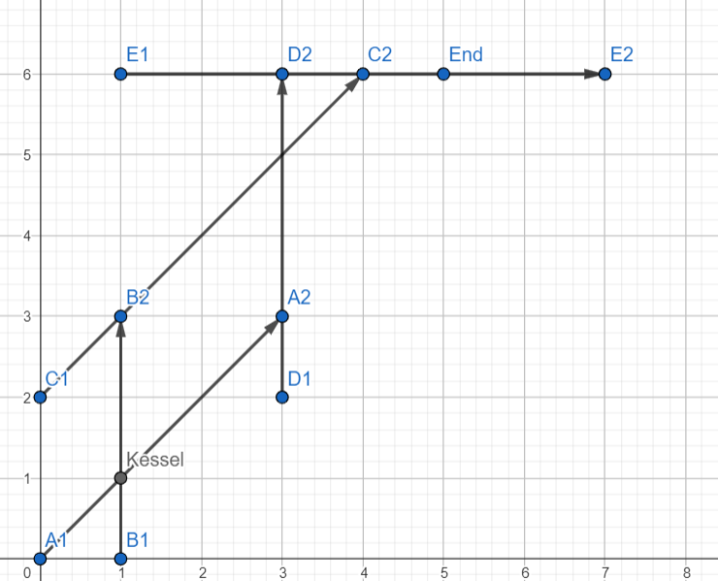
The segments are marked with the letters A,B,C,D,E , and their two points. There are two shortest paths. One of them is for the ship to start at point (1,1) and move to point (3,3) along segment A. After that the ship moves to point (3,5) along segment D. After that it moves to point (4,6) along segment C. Lastly, it moves to the end point (5,6) along segment Е. The sum of those distances is approximately 7.242640687.

