The famous criminal Xarquillianthros Zephyroquinoxius Blazaric Nebulorium Vortexis Andromedae Galaxion Tesseractus has become again a main theme at the Intergalactic Board meeting. Once more, he tries to reveal to humans that extraterrestrial life exists. This time his plan is to draw circles with equal radius R on the surface of the planet Mars (which we imagine as an infinite 2D plane).

Consequently, the Intergalactic Board started scrutinizing the whole planet. However, you are the trusted spy of Xarquillianthros in the Board and managed to find a list of N points, (x1,y1) …. (xN,yN) where the defense is weaker and Xarquillianthros can draw circles with centers among these points.

The only obstacle is that if two circles intersect at more than one point, the Board will notice immediately. Your task is to find the largest set of circles with radius R and centers among the given N points so that no two intersect at more than one point.

**Input**

The first line of the file **mars.in** contains the integers N and R – the count of points and the radius of the circles. Each of the next N lines consists of 2 integers xi , yi  describing the points.

**Output**

On the first line of the file **mars.out** print one integer k – the number of circles that you found.

The next line should comprise of k indices - o1,o2,….,ok . The number oj denotes that the point with coordinates (xoj,yoj) is a center of one of the circles.

**Grading**

If 1) you have more than one circle with a given center, 2) you have 2 circles intersecting at more than one point, 3) oj < 1 or oj>N, 4) the count of circles k is more than N or less than 1, you will receive the message “Error” and 0 points for the test. Otherwise:

For every test let maxScore be the biggest number of circles among the results of all participants. You will receive:

${(\frac{k}{maxScore})}^{1.5}$ multiplied by the amount of points for the test.

**Constraints**

$$1≤N≤{10}^{5}$$

$$1≤x_{i},y_{i}≤{10}^{6}$$

$$1≤R≤{5*10}^{4}$$

**Time limit: 5 sec.**

**Memory limit: 256 MB.**

The tests are spread like this:

|  |  |
| --- | --- |
| Percent of tests | n |
| 20% | $$1≤n≤100$$ |
| 30% | $$100<n≤1000$$ |
| 30% | $$1000<n≤5000$$ |
| 20% | $$5000<n≤100000$$ |

**Sample test**

|  |  |
| --- | --- |
| **Input (mars.in)** | **Output (mars.out)** |
| 8 1  3 3  4 4  4 7  7 5  2 6  5 3  5 5  4 6 | 4  2 4 5 8 |

**Sample test explanation**

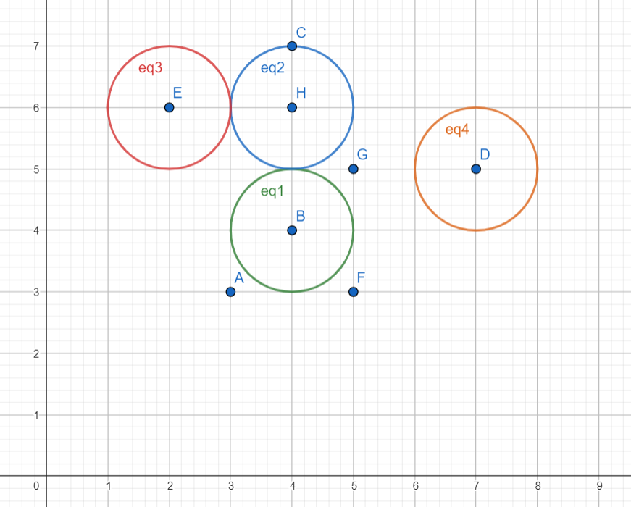The points are denoted with the letters A, B, C, D, E, F, G, H given by the input order. The circles with centers B, D, E, H are drawn. You can see that no 2 circles intersect at more than one point. If we draw a circle with center A, it will intersect the one at B in 2 points and the output will be invalid.