The gala dinner celebrating the anniversary of Lazar’s two companies is approaching. As a result, an appropriate restaurant is to be chosen.
The two companies have a hierarchical structure where the bosses are above their subordinates. There are N workers, working in both companies. However, the structures of the two organizations are different.
Somebody will be given the task to choose the restaurant. Therefore, he will ask his direct subordinates, as well as their direct subordinates and etc. in the first company for their opinion. The worker wouldn’t ask a person that is not also below him in the second firm.
As constantly enhancing, Lazar’s two companies are hiring new employees. They receive a position in both companies as direct subordinates to given workers. Mind that these direct bosses might differ.
You will be given the two hierarchies and the count of queries which you have to process. Every query is one of the two types:
- A new employee with index N+cnt_{q} is hired as a direct subordinate to the employees with indices x_{q} and y_{q} in respectively the first and the second company. cnt_{q} shows the total count of queries of type 1) until the current moment inclusively.
- For a given employee with index p find the count of employees which are below him in the first organization, but the same are not below him in the second organization.

Input
The first line of the file company.in contains a single integer N – the count of workers in the two companies. The next line reads N-1 integers: ${par}_{2}, {par}_{3}… {par}_{N}$ – the indices of the direct bosses of the 2nd, 3rd… N^{th} employees describing the structure of the first hierarchy. The next line similarly describes the second company: ${par_sec}_{2}, {par_sec}_{3}… {par_sec}_{N}$. The next line comprises of Q – the count of queries. Q lines follow, consisting of the queries which are one of the two types:
- $1 , \left(N+{cnt}_{q}\right) , x_{q}, y_{q}$ – hiring of a new employee.
- $2 , p_{q}$ – query for the employee with index $p_{q}$.
Output
In the file company.out print as many numbers as there have been queries from type 2).

Constraints
$$1≤N≤{10}^{5}$$
$$N≤N_{total}≤{1.5*10}^{5}, N_{total} denotes the total count of workers after all queries$$
$$Q=7*{10}^{4} with the exception of a single test where Q=500$$
$$1≤{pаr}_{i}≤N$$
$$1≤x_{q}, y_{q}<N+{cnt}_{q}$$
$$1≤p_{q}≤N+{cnt}_{q}$$

Time limit: 1.4 sec.
Memory limit: 256 MB

Sample test
Input (company.in) | Output (company.out)
6  1 2 2 1 5  1 2 5 6 1  7  2 1  2 5  2 2  2 3  1 7 3 2  2 2  2 3 | 0  1  1  0  1  1

Sample test explanation
In the tables below you can see the two hierarchies.
The answer of the second query is 1 because the 5th employee will not ask the 6th.
In the third query the 2nd employee will not ask the 4th.
In the sixth query the 2nd employee will not ask the 4th.
In the seventh query the 3rd employee will not ask the 7th.

 | Until the 5th query | After the 5th query
First company | 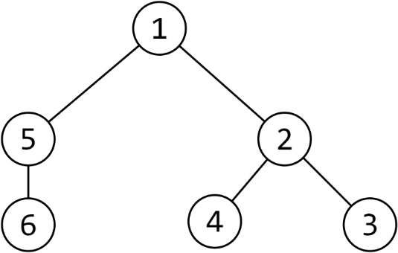 | 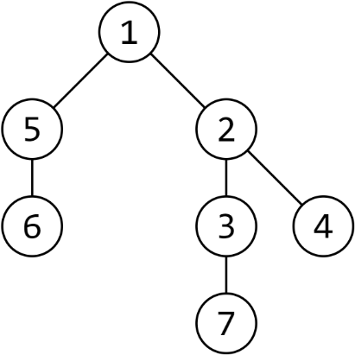
Second company | 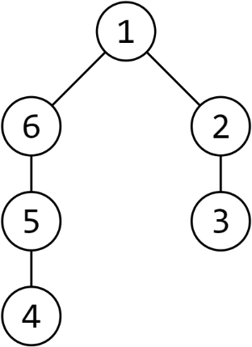 | 