The spring tournament in Informatics is approaching. Pavkata is going to drive his students to the tournament with his car. The road network consists of N cities connected with N-1 segments. Segment $i$ connects cities $i$ and $i+1$.

Every road segment is associated with a positive integer $w_{i}$ meaning that a vehicle with weight more than $w_{i}$ cannot pass this road. Since Pavkata’s students are wondering how much luggage they can borrow, he decided to research the possible itineraries.

Apart from the mainstream roads, Pavkata knows how to get to every city using some alternative roads. This means that he can choose the start city of the journey. In order to make things more interesting, the road controllers decided to change the constraints for the roads.

Just like that, Pavkata came up with a nice task to test his students before the competition: you are given information about the allowed weights on the roads. Q queries follow, each one is of 2 types: 1) the maximum allowed weight of a vehicle on road $p_{i}$ becomes $d_{i}$; 2) If the car starts the journey from city $q_{i}$ and weighs $k_{i}$, how many cities in total can be visited, abiding by the current road constraints.

**Input**

The first line of the file **roads.in** contains two integers N and Q. The second line of the file contains N-1 numbers – $а_{1}, а_{2}, … а_{n-1}$, describing the maximum allowed weights on the roads. Q lines follow, describing the queries. They are 2 types:

* 1 $p_{i}$ $d_{i}$– road with index $p_{i}$ changes its maximum allowed weight to $d_{i}$
* 2 $q_{i}$ $k_{i}$– starting the journey from city $q_{i}$, weighing $k_{i}$, how many cities in total can be visited following the current constraints

**Output**

For each query of type 2 print 1 number in the file **roads.out** – the number of cities.

**Constraints**

$$1≤N, Q≤{10}^{5}$$

$$1≤p_{i}≤N-1$$

$$1≤q_{i}≤N$$

$$1≤a_{i},k_{i},d_{i}≤{10}^{9}$$

**Time limit: 0.7 sec.**

**Memory limit: 256 MB**

**Sample test**

|  |  |
| --- | --- |
| **Input (roads.in)** | **Output (roads.out)** |
| 10 10  4 5 1 7 9 10 3 6 5  2 2 3  1 3 8  2 2 3  2 4 6  2 7 6  1 6 3  2 7 6  2 4 5  1 7 7  2 9 1 | 3  10  5  5  1  5  10 |

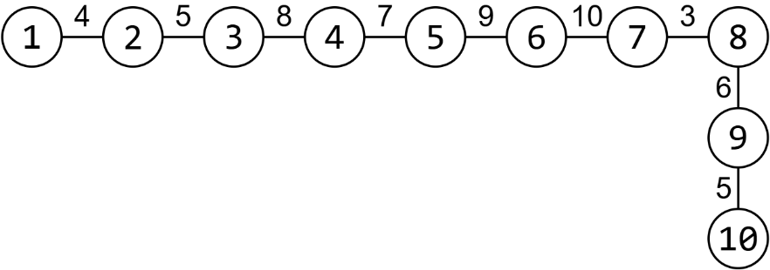**Sample test explanation**

After the second query the road network looks like this (on the right). If the journey starts at city 2, the car weighing 3, all 10 cities will be possible to be visited, since the maximum allowed weight for all roads is at least 3.

The following cities can be visited in the 4th query: 3, 4, 5, 6 and 7.