Bochi finally got up from his computer to go to school. Since the boy has no sense of direction, his mother gave him a map of Sofia. Sofia consists of N buildings (numbered from 1 to N) with M streets between them, so there is a path between every building and every other building. Bochi uses the streets to get to school, but the route he takes is a mysterious sequence, unknown to anyone (even to Bochi).

His mother has no idea where Bochi will go, so she worries that he might enter The Mall, and when that happens she is sure her son will get lost and won't be able to get out. The mall is located in building number V while Bochi's house is in building number U. Bochi's mother wants to remove certain streets from the map, so that it becomes impossible for Bochi to pass through the mall.

However, Bochi has started to develop a bit of spatial orientation. For each street j, his mother knows cj — how many times Bochi has passed through this street in his life. To be as sure as possible that the boy will not suspect anything, she wants to find such a set of streets S to remove that the sum of the values $\sum_{j∈S}{c_{j}}$ is minimal.

She gives you N, M, U, V, and the map of Sofia along with the street values, and asks you to write a program that finds the sum of the values of the streets in the cheapest set of edges to remove, so that no path exists from U to V.

**Input**

The first line of the file **city.in** contains N, M, U and V – the amount of buildings, streets and the numbers of Bochi’s house and The Mall. Each of the next M lines contains three numbers аj , bj, cj describing that street j connects the buildings with numbers aj and bj and Bochi has passed through it cj times.

**Output**

On the only line of the file **city.out** print 1 number: the desired minimum sum.

**Constraints**

$$1≤N≤{3*10}^{5}$$

$$1≤M≤N+1000$$

$$1≤U,V,a_{j},b_{j}≤N$$

$$1≤c_{j}≤{10}^{5}$$

**Time Limit: 1 sec.**

**Memory Limit: 256 MB.**

**Sample Test**

|  |  |
| --- | --- |
| **Input (city.in)** | **Output (city.out)** |
| 12 16 2 1  3 6 4  3 4 7  6 1 8  1 7 3  4 2 9  4 5 10  2 8 3  2 9 6  9 10 7  9 11 2  10 12 5  9 8 4  3 10 5  12 7 60  6 12 1  12 11 3 | 8 |

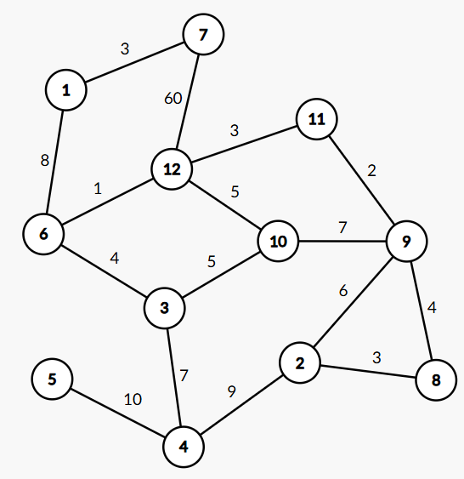 **Sample Explanation**

Bochi's house is in building number 2 and the mall is in building number 1.

There are many sets that make the journey from 2 to 1 impossible, but the one with the smallest sum is to remove the streets connecting 1-7, 6-12, and 6-3.

After removing these buildings 1 and 6 are isolated from the rest of the city, and it is impossible for Bochi to reach them.

An example of another set that meets the conditions is to remove the streets connecting 11-12, 10-12, 3-10, and 3-4, but the total sum in this case is 20, which is greater than the optimal sum of 8.