Bozhko will celebrate his birthday in Dolni Dabnik, and you will party like it's the last time. Uncle Niki will try his best to send all the guests to their hometowns when they deem it best. He will drive them in his car – the "Toyota Jaguaris".

When a child arrives at the birthday party, their dissatisfaction with going home is quite significant - after all, they have just arrived. After some time, the ideal moment for going home arrives – tiredness has taken over. If the child stays after this moment, they become more and more irritated. A study shows a strong correlation between this behavior and the child's hometown. Based on this logic, for each city $i$, we define an integer sequence of dissatisfaction with going home ${cost}_{i}$, which is known to be initially non-increasing, reaching a minimum, and then becoming non-decreasing. Every child from city $i$ behaves with a sequence ${cost}_{i}$.

Uncle Niki's car can fit up to 4 people. He has information about which city each child lives in. The road network he travels on consists of N cities and M roads that connect them. Dolni Dabnik is located in city 1.

Each road segment has a specific length – an integer number of kilometers. When Niki is about to drive a child from city number $i$ at an integer moment $t$, they get into the car with a dissatisfaction coefficient equal to ${cost}_{it}$. We will call the sum of the dissatisfaction coefficients of the children present in the car *the travel coefficient*. We define the travel cost as the sum of the travel coefficient for each kilometer traveled. When a child gets out of the car, the travel coefficient decreases by their dissatisfaction. The earliest moment Niki can start traveling is 1, and the latest is 2000.

The "Jaguaris" is so fast that we do not account for the time it takes for Niki to travel between cities – therefore, he is ready for a new trip at every integer moment. When he arrives in a city where any of the passengers live, all passengers who are from that city get out of the car. Each route must pass through no more than 4×N cities, and it is allowed to pass through any city more than once, as long as the car travels on valid road segments.

Your goal is to distribute the children among some trips that the car can make and to choose good routes in order to reduce the total travel cost as much as possible.

**Input**

The first line of the file **transport.in** consists of N, M, G – the count of cities, count of roads and count of children. The second line contains G integers – the hometowns of the children - $d_{1}, d_{2}…d_{G}$. Description of the $cost$ sequences follows – N x 2000 table with integers. Line $i$ contains the values ${cost}_{i1},{cost}_{i2},{cost}_{i3}…{cost}_{i2000}$. Each of the last M lines consists of 3 numbers: $u_{j}, v_{j}, w_{j}$, denoting a 2-way road between $u_{j} and v_{j}$ with a length $w_{j}$.

**Output**

On the first line of the file **transport.out** print a single integer T: count of routes which Niki will do. Each of the T routes should start with 3 integers - $r_{i}, K_{i}$, $H_{i}$ denoting that the i-th route takes place at moment $r_{i}$, the car has $K_{i}$ children and it travels through $H_{i}$ cities. $K_{i}$ numbers follow, describing the children indices. The next $H_{i}$ integers comprise of the cities along the route. The time moments $r_{1}, r_{2}, … r_{T}$ should be increasing.

**Scoring**

If 1) $T>G$; 2) $K_{i}>4$ or $K_{i}<1$; 3) an index of a child is not present at all or is present more than once among all routes; 4) $r_{1}, r_{2}, … r_{T}$ do not form increasing sequence ; 5) $H_{i}>4*N$; 6) $r_{T}>2000$, 7) the route does not start at 1 or is invalid, you will receive a message “Error” and 0 points for the corresponding test. Otherwise:

yourScore = total travel cost from all routes

Let minScore be the smallest cost among all participants. You will receive

$(1-\sqrt{1-\frac{minScore+1}{yourScore+1}})$ multiplied by the points for this test.

**Constraints**

$${1≤cost}_{ij}≤{10}^{4}$$

$${1≤u}_{j},v_{j}≤N$$

$${1≤w}_{j}≤1000$$

$$20≤N≤200$$

$$100≤G≤1000$$

$$100≤M≤1000$$

**Time limit: 5 sec.**

**Memory limit: 256 MB.**

**Test Spread:**

|  |  |  |  |
| --- | --- | --- | --- |
| N | M | G | Test percentage |
| N = 20 | М = 100 | G = 100 | 25% |
| N = 50 | М = 250 | G = 250 | 25% |
| N = 100 | М = 500 | G = 500 | 25% |
| N = 200 | М = 1000 | G = 1000 | 25% |

*The sample test is only illustrative and therefore, does not meet the constraints of the problem, for example, the cost table does not contain 2000 columns. In the tests section, you can find an example test that meets the constraints for the first subgroup.*

*Output*: The sample output contains comments inside brackets for clarity. Your output should not contain such comments.*

**Sample test**

|  |  |
| --- | --- |
| **Input (transport.in)** | **Output* (transport.out)** |
| 6 8 8  1 3 2 4 5 2 6 1  20 15 13 5 7 10 11 20 30 35  15 14 13 12 11 12 13 14 15 16  19 10 3 4 9 13 15 17 18 19  40 35 33 30 29 20 10 5 10 11  25 1 3 4 5 10 15 20 25 35  30 29 5 1 4 5 6 7 10 30  1 4 5  6 3 6  2 4 4  1 5 7  1 3 8  5 6 1  2 3 4  5 4 3 | 3 (count of routes)  2 2 4 (moment 2, 2kids, 4cities)  2 5 (indices kids; cities: 3 & 5)  1 3 6 5 (route)  4 3 3  1 7 8 (cities 1 & 6)  1 5 6  8 3 3  3 4 6 (cities 2 & 4)  1 4 2 |

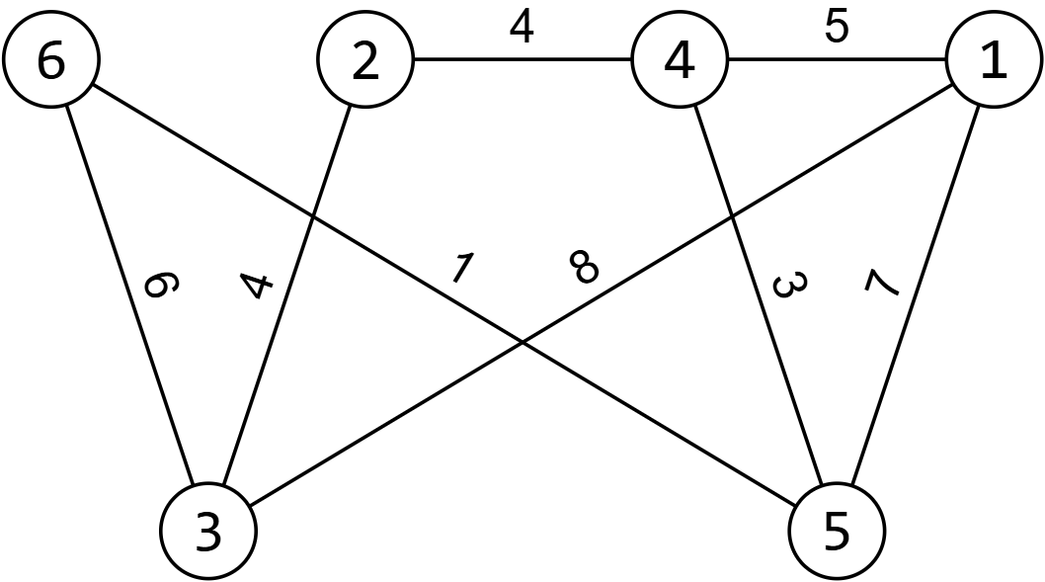**Sample test explanation**

On the right, you can see the road network. The proposed trips are 3 in total. The first is at moment 2, with 2 children in the car – from cities 3 and 5, and the route goes through cities 1, 3, 6, and 5.

Travel cost for route 1: 8 * 11 (first segment) + 1 * 6 (child number 2 has gotten off) + 1 * 1 = 95.

Travel cost for route 2: In city 1, the first and eighth children get off. The city of child 7 is 6 => the travel coefficient at moment 4 is 1; 1 * 7 + 1 * 1 = 8.

Travel cost for route 3: At moment 8, the travel coefficient for cities 2 and 4, from where children 3, 4, and 6 are, is 2 * 14 + 5 = 33. Then: 33 * 5 (first segment, child number 4 gets off) + 28 * 4 = 277.

YourScore = Total travel cost = 95 + 8 + 277 = 380.