A Grand Prix race is upcoming, and preparations are more than intensive. Desi is a huge Ferrari fan and got exclusive tickets for one of the drivers' training sessions.

The training track resembles a tree – an undirected connected graph without cycles – with N sectors – the vertices of the tree. In each sector, there is a flag with a small Latin letter on it. The drivers are given Q pairs of sectors, which define the starting and ending points of their drive. Along the path between these 2 sectors, the drivers must count the palindromes formed by letters written on flags located in adjacent sectors. In other words, they need to count how many palindromic substrings (formed by removing some letters from the beginning and end of the string) there are in the string formed by the letters from the flags along the path between the two sectors.

This activity is key to improving the team's results. Help by writing a program that counts the palindromes.

**Input**

The first line of the file **ferrari.in** contains the integer N. The second line reads string S with N small Latin letters. The next N-1 lines are comprised of pairs of integers, denoting the segments connecting the sectors: $u_{i}, v_{i}$. The next line consists of Q – the number of pairs of sectors from the training session. Q pairs follow – the starting and ending sectors for driving: $p_{j}, q_{j}$.

**Output**

Print in the file **ferrari.out** Q lines with 1 integer – the count of palindromes for each pair of sectors you have to drive between.

**Constraints**

$$N=2000$$

$$Q=200000$$

$${1≤u}_{i}, v_{i}≤N$$

$$1≤p_{j}, q_{j}≤N$$

**Time limit: 0.3 sec.**

**Memory limit: 256 MB**

**Sample test**

|  |  |
| --- | --- |
| **Input (ferrari.in)** | **Output (ferrari.out)** |
| 7  aacaccb  1 3  1 2  3 4  4 5  2 6  2 7  3  4 6  2 6  1 5 | 8  2  6 |

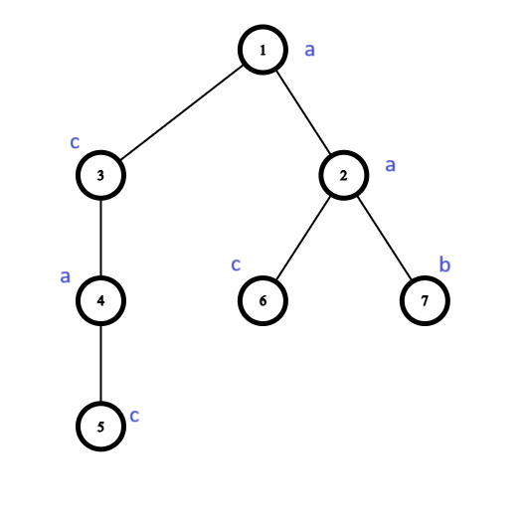**Sample test explanation**

You can see the track on the right. The string formed on the road between sectors 1 and 5 is “acac”. The number of substrings which are palindromes are 6: “a”, “c”, “a”, “c”, “aca”, “cac”.