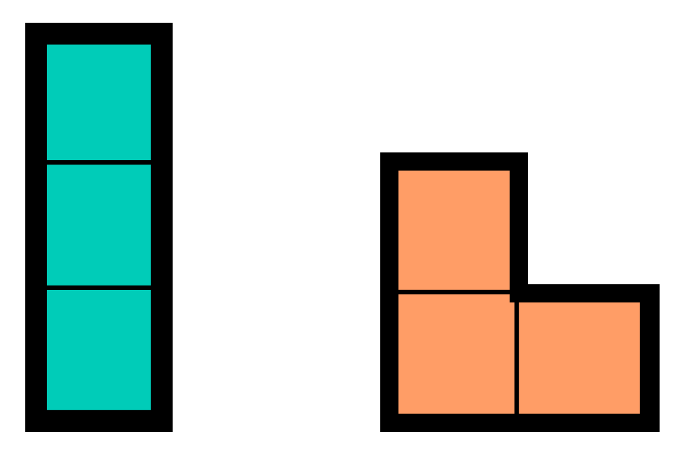A survey on the social network "Grid Tok" indicates that dominoes are no longer trendy. On the other hand, trominoes are gaining increasing popularity – these are figures made of 3 squares connected to each other by their edges. On the right, you can see the two basic trominoes. Their 90, 180, and 270-degree rotations are also considered trominoes.

Deni and Pepi have come up with the following challenge. You are given an NxN square grid of cells, which is covered with trominoes. You are also given an NxN table with the points that each cell carries. The goal of the challenge is to maximize the collected points by moving around the grid. Movement follows these rules:

* You start from any cell you wish.
* You finish in any cell you wish.
* From a cell $(i, j)$ you can move to any adjacent cell, provided it is within the grid boundaries: $(i+1, j)$, $(i, j+1)$, $(i-1, j)$, $(i, j-1)$, $(i-1, j-1)$, $(i+1, j+1)$, $(i-1, j+1)$, $(i+1, j-1)$
* Each cell can be visited at most once.
* It is allowed to move to a cell from an already visited tromino, as long as that specific cell hasn't been visited yet.
* Visiting more than 2 cells from the same tromino is forbidden.

Regarding scoring, the following rules apply:

* When visiting any cell from an unvisited tromino, you receive the points that the newly visited cell carries.
* When moving to an unvisited cell from an already visited tromino, the points that the newly visited cell carries are subtracted from your accumulated score.

You start your search for the optimal path with 0 points. Collect as many points as possible.

**Input**

The first line of the text file **traversal.in** contains the number N - the size of the grid. Each of the next N lines consists of N integers in the range: $[1; (N*N)/3]$, separated by a single space, describing the index of the tromino the given cell belongs to. It is guaranteed that the cells with the same value form a tromino. The table with points follows – N rows with N integers. The rows in the grid are numbered from top-to-bottom, and the columns from left-to-right, with numbers from 1 to N.

**Output**

The first line of the file **traversal.out** should contain K – the count of cells from your route. On the each of the next K lines print a pair of integers describing the coordinates of the cells from your route – $x_{1},y_{1}$; $x_{2},y_{2}$… $x_{K},y_{K}$.

**Scoring**

If you don’t comply with the rules for movement, your route will be regarded as invalid and you will receive a message “Error” and 0 points for the corresponding test. Otherwise:

$$yourScore =max⁡(accumulated number of points,1)$$

Let maxScore be the biggest amount of points accumulated among all participants. You will receive ${(\frac{yourScore}{maxScore})}^{1.5}$ multiplied by the points for that test.

**Constraints**

$1≤a_{ij}≤\frac{(N*N)}{3}$*, where $a_{ij}$ is the index of the tromino that cell (i, j) belongs to.*

$$60≤N≤600$$

${10}^{4}≤{points}_{ij}≤{10}^{5}$*, where ${points}_{ij}$ means the number of points in cell (i, j).*

**Time limit: 5 sec.**

**Memory limit: 256 MB**

**Test Spread**:

|  |  |  |
| --- | --- | --- |
| Test percentage | N | Additional constraint |
| 25% | $$N=60$$ | - |
| 25% | $$N=150$$ | - |
| 25% | $$N=600$$ | ${points}_{ij}=10000$, for all cells |
| 25% | $$N=600$$ | - |

*The sample test is only illustrative and therefore, does not meet the constraints of the problem, for example, the points table does not contain numbers above ${10}^{4}$. In the tests section, you can find an example test that meets the constraints for the first subgroup as well as the sample test below.*

**Sample test**

|  |  |
| --- | --- |
| **Input (traversal.in)** | **Output (traversal.out)** |
| 6  1 1 1 2 3 4  5 7 2 2 3 4  5 7 7 8 3 4  5 10 10 8 8 9  6 10 11 11 11 9  6 6 12 12 12 9  10 15 13 11 20 18  11 14 18 13 13 17  9 20 4 4 6 10  11 13 15 19 20 12  14 22 11 8 10 14  21 18 11 10 15 16 | 12  1 5  1 6  2 5  2 4  3 3  4 4  5 3  5 2  4 1  3 1  2 2  1 2 |

|  |  |  |  |  |  |
| --- | --- | --- | --- | --- | --- |
| 10 | 15 | 13 | 11 | 20 | 18 |
| 11 | 14 | 18 | 13 | 13 | 17 |
| 9 | 20 | 4 | 4 | 6 | 10 |
| 11 | 13 | 15 | 19 | 20 | 12 |
| 14 | 22 | 11 | 8 | 10 | 14 |
| 21 | 18 | 11 | 10 | 15 | 16 |

**Sample output explanation**

On the right, you can see the grid. The numbers in the cells indicate the points in that cell, and the **colors mark the different trominoes.** Note that the colors are only used to distinguish different trominoes from neighboring ones – only 5 colors are used instead of 12.

|  |  |  |  |  |  |
| --- | --- | --- | --- | --- | --- |
| 0 | +15 | 0 | 0 | +20 | +18 |
| 0 | -14 | 0 | +13 | -13 | 0 |
| -9 | 0 | +4 | 0 | 0 | 0 |
| +11 | 0 | 0 | +19 | 0 | 0 |
| 0 | +22 | +11 | 0 | 0 | 0 |
| 0 | 0 | 0 | 0 | 0 | 0 |

On the left, you can see how each cell contributes to the answer. **Positive numbers** are in cells whose figures we visit for the first time. **Negative numbers** are in cells whose figures we visit again. In this case, yourScore = 97