Visualiser

For your convenience we provide you with a visualiser which simulates the transformations your solution prints. The visualiser works only with “.jpg” files with size of 200x200 pixels. The working directory of the visualiser is WindowsFormsApplication2\bin\Debug, you should put there the executable file you want to run. In order for your program to work with the visualizer it should read from the standart input and print to the standart output(but when you upload your program on the CodeIt website it should read from “transformation.in” and print to “tranformation.out”. The visualiser has the following functions:
generate input - You chose two pictures and the number of operations. The button “generate input” creates the input file mytask.in that contains the test case in which the first picture is the left one you selected, the second picture is the right one you selected and the maximum number of operations is equal to the number of operations you selected.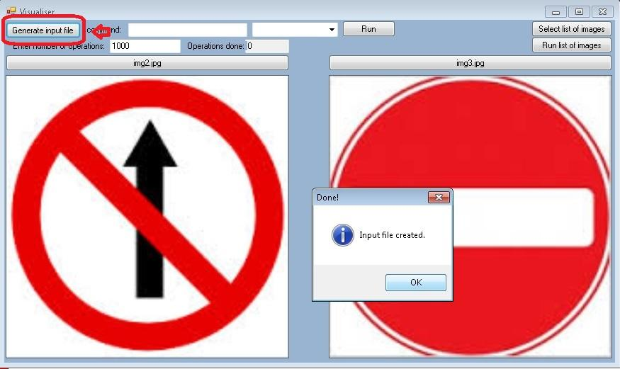
run - You should chose to pictures, a command that runs your solution and maximum number of operation. The button “run” visualise the changes that your solution makes on the first picture. Finally it tells you your score for the test.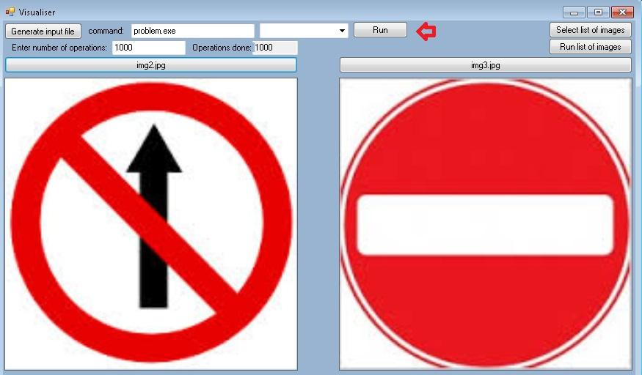
run list of images - Using the button “Select list of images” you can chose a list of images that you want to test. Type the command that runs your solution and chose the maximum number of operations. The button “Run list of images” visualise the performance of your solution on each pair of images in the list. Finally the visualiser creates a file score.log that tells you the results that your solution gets on each of the tests.

From the drop menu you can choose the speed with wich your program will be simulated.
The results that tells you the visualiser equal to ‘yours’ in the grading formula.

Opening the visualiser
In order to open the visualiser you need the archive uploaded on our website and Microsoft Visual studio (the recommended version is 2012) - http://www.microsoft.com/en-gb/download/details.aspx?id=34673.
After you unzip the archive in an appropriate directory open the folder WindowsFormsApplication2 and open the file “round5Visualizer.sln”. Wait for Microsoft Visual Studio to load and start the visualiser by typing“ctrl + f5”.

