The jury has prepared visualizer which represents the competitors’ solutions in CodeIT Round 5.
You can download the code of the visualizer from this page http://codeit.bg/bul/round/46
Visual C#
The visualizer is written in C#. Before you start using in you have to build it. For this you will need Microsoft Visual Studio. During the development the jury has used the version from 2015 year and we strongly recommend using that version. You can download free version of Visual Studio from: https://go.microsoft.com/fwlink/?LinkId=691978&clcid=0x409.
The visualizer is developed under Windows and it is not guaranteed that you can use it on other operation systems.
Building the visualizer
After you have downloaded the visualizer’s code archive you have to build it. You have to open the CodeIT-Puzzle-Visualizer.sln file with Visual Studio. The file is located in the folder CodeIT-Puzzle-Visualizer. After the solution opens you have to hit Ctrl + F5. You have to wait until the visualizer builds and it will start automatically.
Usage
After you start the visualizer you will see 4 buttons and red and green squares.
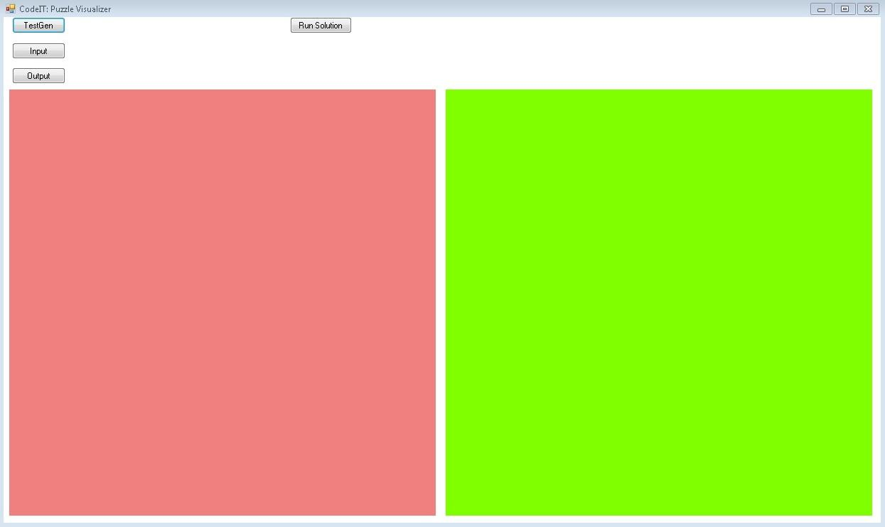
The first button – „TestGen“ will generate for you by a given image 200*200 pixels test with random parameters. It is not guaranteed that solution to that test exists. You can set parameters to the generated test. You will have to uncomment row 757 or 758 in the file form1.cs and give value to the variables rbs и swpcnt. The variable rbs contains the size of the zones and it must be 1,2,5,10 or 20, аnd swpcnt – how mixed is the image. The bigger the value of that variable is, the more changes the messed up picture contains. The official tests are not made with that generator. It is developed only for the participants. The test will be saved in the folder \CodeIT-Puzzle-Visualizer\CodeIT-Puzzle-Visualizer\bin\Debug
The next button is „Input“. If you want to run test example from input and output file you have to use this button and choose valid input file. If the file is not valid the visualizer will return you error message. The input file must be with extension “.in”. The name doesn’t matter. If the file is correct on the place of the green and the red square will appear two images – the puzzle and the original one.
The button „Output“ will give you the possibility to choose output file for the entered input. It must consist of 2 numbers – the coordinates of the removed zone and string which show the moves your program makes. If the file is not valid the visualizer will return you an error message.
The button “Run Solution” will give you the option to choose solution to visualize. After you choose the file it will execute. If it finishes successfully, the visualizer will return the execution time and will search the folder from your solution for files called puzzle.in and puzzle.out. If this files are not found or have some problems the visualizer will return you error message. If they are OK, the next menu will show.
If everything with the input and output file is OK the visualizer will go to the next visualizing options. You have to set time interval between moves.
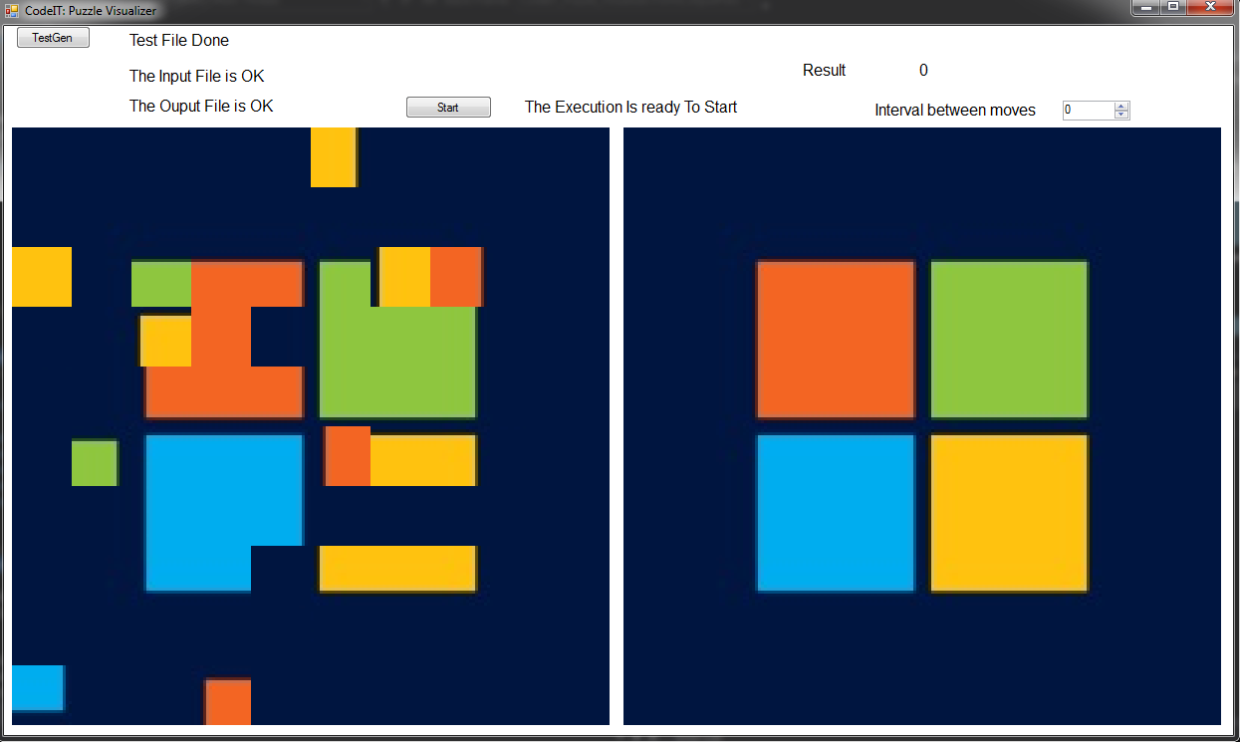
It offers 3 visualizing options.
If in the interval field you enter -1, the visualizer will not show your moves. It will show only the final image after your solution and your result.
If you choose 0, the visualizer will wait for you to hit a special button called “Next Move” At the beginning of the visualizing it will be called „Remove Zone“.
If you set interval between 1 and 5000 the visualizer will show each your move after X milliseconds. X is the value you set. During the visualization you will have the possibility to pause/start it with the button “Pause/Continue”.
During the visualization you will see the current coordinates of the empty zone, the number of the current move and its type. If the empty zone leaves the puzzle borders the visualization will stop with proper message.
After the visualization finishes the visualizer will give you the option to see the penalty points you have, option to replay your solution or option to restart the program and choose other solution.

