There is a square shaped room, defined by the coordinates of its bottom left corner (0, 0) and the coordinates of its top right corner (1000, 1000). There are N “unstable” fields – segments (x1, y1, x2, y2) where x1, y1, x2, y2 are between 0 and 1000.
A robot needs to walk through the room in a straight line by entering through the left wall and exiting through the right wall, not crossing any “unstable” fields (but it can touch them). The robot is not a point (it has a certain width), so it cannot always escape from the room – its path could be blocked by “unstable” fields.
Example of a successful escape:
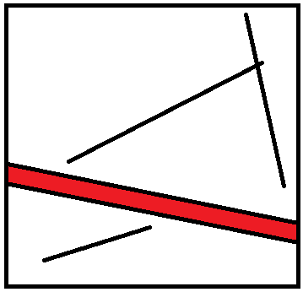
Ivancho wants to construct a robot with maximum width, which would be able to escape from the room. He wonders what that width is.

Input
The first line of the input file escape.in contains the integer N. Each of the following N lines contain four integers x1, y1, x2, y2, describing the coordinates of the first and the second point of the current segment.

Output
In the output file escape.out write a single real number – the maximum width of the robot. Write the number with four digits after the decimal point.

Constraints
1 ≤ N ≤ 60
0 ≤ x1, y1, x2, y2 ≤ 1000

Time limit: 2.0 sec
Memory limit: 256 MB

Example
Input (escape.in) | Output (escape.out)
4  785 618 829 598  700 757 660 762  244 135 268 178  337 687 356 674 | 503.7460

Notice – when outputting in C/C++ with printf use %f for double and %Lf for long double.

