In order to help the participants in round 5 of CodeIT.bg the jury has created a visualizer, which will simulate the moves of a given solution.
You can download the visualizer from this page - <ЕДИ КОЯ СИ>

Usage
First, run Geometry_Visualizer.exe. You will see the following window
There are 3 buttons – Input, Output and Generate Test.
Input – this button will allow you to choose an input file (.in file).
Output – this button will allow you to choose the output file (.out), which your program has produced.
Generate Test – this button will start the random test generator, which you can use to generate example test cases (.in files). (Note: the test generator provided with the visualizer is not the same as the one used for generating the actual tests).
The test generator looks like this:
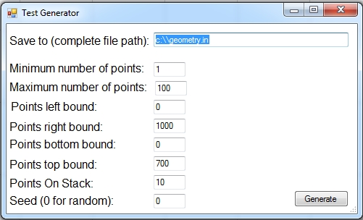
To generate a test you must enter the minimum and maximum number of points you want the test to contain, the largest and smallest value of the x-coordinate, which you want the points to have and the smallest and the largest value of the y-coordinate, you want the points to have (by default these values are the restrictions in the problem statement), how many points you want the stack to contain (for operation 3), and the last field, which is optional, gives you the option to provide a seed for the random test generator. Given the same restrictions and the same seed the generator produces the same test. If the value of seed is 0 a random test will be generated.

After providing valid Input and Output files, all of the buttons of the visualizer will become available.
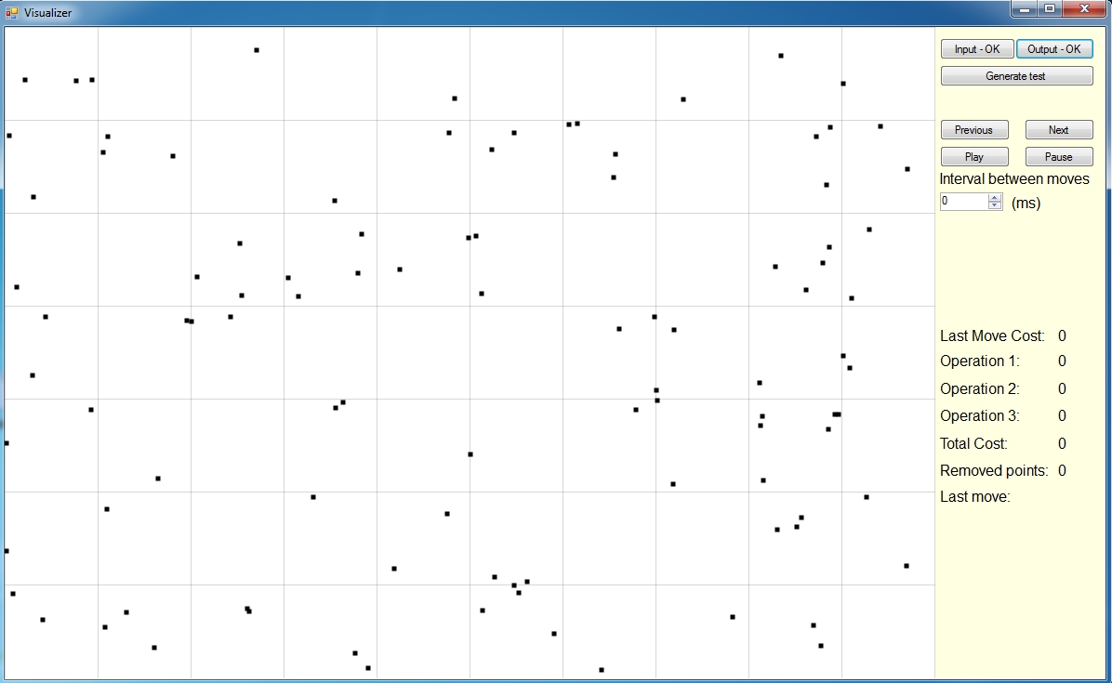
Previous и Next – these buttons can be used for manual simulation of the program – the button Next works in two steps, and colours all points affected by the current operation. On step 1 all points removed (or just moved) by the current operation are shown in red and all points which are used by the operation, but are unchanged – in blue. On step two all new points are shown in green.
NOTE: You can simulate the functions of the buttons Previous and Next using, respectively, the left and right arrow keys.
Play и Pause – these buttons start and pause the automatic visualization. When the button Play is pressed a click of the button Next will be simulated every T milliseconds, where T is the number in the box Interval between moves.
ЗАБЕЛЕЖКА: You can use SPACEBAR to simulate a click of Play/Pause.
ЗАБЕЛЕЖКА 2: The number Т can be edited while visualization is running.
The rest of the fields you seeна will be update during visualization and are used to track the cost of the operations your program uses.

Last move cost - the cost of the operation which was used last.
Operation X – the total cost incurred from using operation X, up to a given moment.
Total cost –the total cost you program has incurred up to a given moment.
Removed points – the number of points which your program has displaced outside the grid up to a given moment.
Last move – the operation which is currently being executed.

At the end of visualization the bounding lines will be drawn and the fields Distance and Final Score will appear where the distance between the lines and score your program has achieved will be displayed.
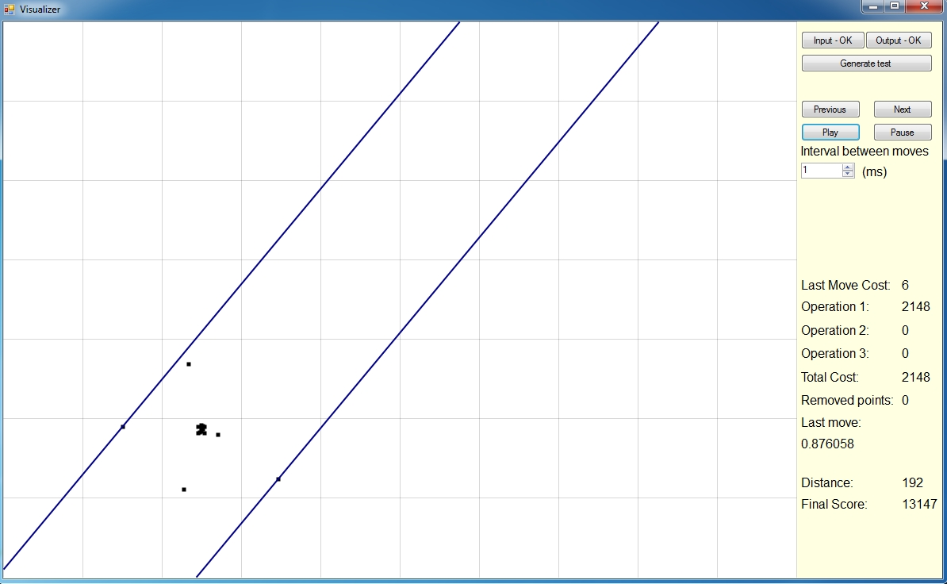
For visualizing a second test case or restarting the current one you simply need to load new input and output files. You do not need to restart the visualizer.

The jury wishes you success in the marathon!

