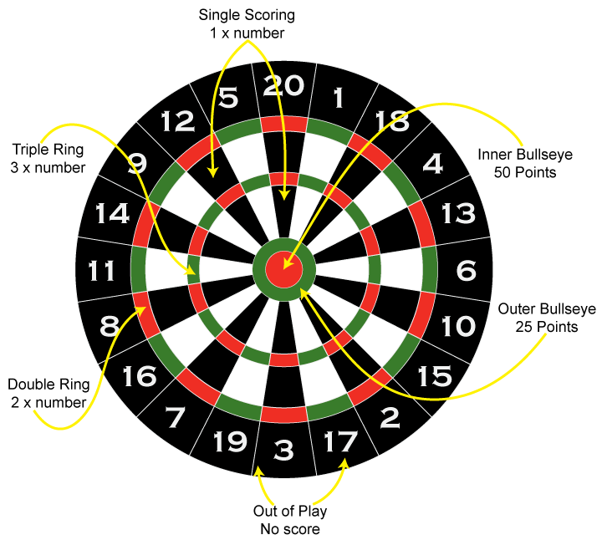
501 is the most simple and popular darts game. Each player starts with a score of 501 and takes turns to throw 3 darts. The score for each turn is calculated and deducted from the players total. The objective is to be the first player to reduce the score to exactly zero.
The darts board is divided into 20 parts corresponding to the numbers from 1 to 20. Each of these 20 parts contains a single sector that gives points equal to its value, a double sector that gives points equal to the corresponding number multiplied by 2 and a triple sector, which gives points equal to its value multiplied by 3. The center of the darts board is divided into two parts. The outer (outer bullseye) circle gives 25 points and the inner (inner bullseye) is a double and gives 50 points. (See the picture for more detailed information)

In a 3-arrow throw, the maximum number of points that can be reached is 180 (3 x 60). In order to win the game, you have to make the so-called "checkout". “Checkout” is scoring exactly the score that is left, to win the leg. Also, in order to win, the last dart thrown must land in a double or the inner bullseye.

A common problem for darts players is to understand whether and how many ways are there to "clear" all of their remaining points. You are asked to write a program that calculates how many different ways this can be done when the remaining points are N.

Keep in mind that it is possible for the player to miss the target (to score 0 points). (see examples)

Two checkouts are different if they have a different number of throws (1, 2 or 3), or if one of the arrows was thrown in a different sector.

Input
The first line of the input file darts.in contains a signle integer N – the remaining points.

Output
In the output file darts.out print one integer – the answer to the problem.

Constraints
1 ≤ N ≤ 180

Time limit: 1.0 sec
Memory limit: 256 MB

Sample tests
Input (darts.in) | Output (darts.out)
4 | 10
168 | 0
50 | 1371

Clarifications

In the first sample the different ways to reach clear 4 points are:
With one throw:
- double 2
With two throws:
- miss and double 2
- 2 and double 1
- double 1 and double 1
With three throws:
- miss, miss and double 2
- miss, 2 and double 1
- miss, double 1 and double 1
- 1, 1 and double 1
- 2, miss and double 1
- double 1, miss and double 1
So there are 10 different ways to checkout from 4.
In the second example it is impossible to clear the remaining points with 3 shots.
You can read more about the darts game 501 game here:
http://www.nicedarts.com/how_to_501

