Let $n$ be a natural number. You have infinitely many figures of 4 types:

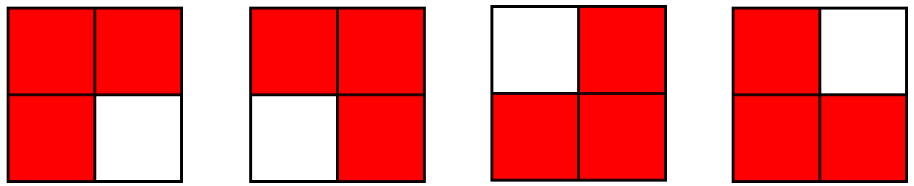

Formally, they are obtained by removing one square from a 2 by 2 square. Consider a $n$ by $n$ square. You want to place the maximum number of figures in this square so that none of them comes out of the square and no two overlap. Find that amount and print an example that achieves it. Answer $t$ such tests.

**Input**

The first line of the file **figures.in** contains the number $t$. Each of the next $t$ lines contains one number - $n$ for the corresponding test.

**Output**

Print the answer $x$ of each test on a new line in the file **figures.out**, and then $n$ lines of $n$ numbers each that describe the corresponding example. In the example, each number from 1 to $x$ must occur exactly 3 times and they must form a figure of the types described, and the remaining cell must be 0, indicating an empty cell.

**Constraints**

$$1≤t≤10$$

$$1≤n≤200$$

**Time limit: 0.6 sec.**

**Memory limit: 256 MB.**

**Sample test**

|  |  |
| --- | --- |
| **Input (figures.in)** | **Output (figures.out)** |
| 2  1  4 | 0  0  5  1 1 2 2  1 3 3 2  4 3 0 5  4 4 5 5 |