Kyusho decided it‘s time take a break from all the stress of running the company and go on a family trip. After some intense thinking, he chose N destinations and M direct one-way roads to move along between them. To maximize the satisfaction of the tour, he wants to visit each of the destinations exactly once and after visiting the last one to be able to go directly back home. Thus, he made T plans for destinations and road segments between them, and since he is running out of time, he asks you to determine for which of them there is a route of the described type. One last detail Kyusho thinks might be helpful is the strange property he discovered for each plan while reviewing them:
If for two destinations A and B there is a destination C such that there are direct roads from A and B to it, then any other destination D to which there is a road segment from A or B is like C (there is a direct road from both A and from B to it).
Put differently, if we call destination Y a neighbour of X when there is a road segment from X to Y, then if two destinations have at least one neighbour in common, all of their neighbours are common.
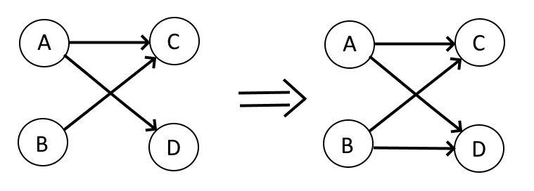

Input
From the first line of the file eksk.in the number T is given. For each plan the first line contains N and M followed by M lines with two numbers X and Y, specifying that there is a one-way road from destination X to destination Y (0 ≤ X, Y ≤ N; 0 indicates the modest mansion of Kyusho (the property described above applies also for it), and the numbers from 1 to N - the numbers of the destinations).

Output
For each of the T plans, print in the file eksk.out on a separate line YES, if there is a route visiting each destination once and NO otherwise. If the answer is YES, on the next line, print N + 2 integers (the first and last of which are 0), describing the destinations in the order of their visit. If there is more than one possible routes, print any of them.

Constraints
$$1≤T≤{10}^{2}$$
$1≤$sum of all N $≤{10}^{5}$
$1≤$sum of all M $≤{5×10}^{6}$
$0 ≤X,Y≤N$ and $X≠Y$ for each road segment

Time limit: 1.2 sec.
Memory limit: 256 MB.

Sample testcase
Input (eksk.in) | Output (eksk.out) | Explanation
1  6 11  1 3  2 3  1 4  2 4  3 5  5 6  4 6  4 0  5 0  0 1  6 2 | YES  0 1 4 6 2 3 5 0

